HR Workflow Designer

A visual workflow-building tool that allows HR teams to design, configure, and simulate internal HR processes such as onboarding, leave approval, and document-verification workflows.
This prototype demonstrates:
- React + React Flow canvas rendering
- Custom workflow node types
- Editable configuration forms
- A mock API layer (GET /automations, POST /simulate)
- A workflow simulation panel
- Scalable architecture using hooks, modular components, and typed interfaces

📁 Project Structure
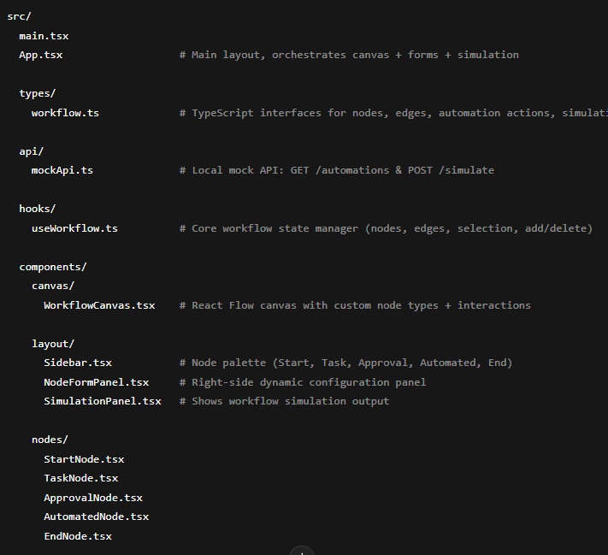
🚀 Features
✔️ 1. Workflow Canvas
Implemented using React Flow:
- Drag workflow nodes into the canvas
- Connect nodes
- Delete nodes & edges
- Auto-validation (Start node must be first, every node must be connected)
✔️ 2. Custom Workflow Nodes
Each node type has:
Node Type | Purpose
Start Node | Workflow entry point
Task Node | Human task requiring documents or actions
Approval Node | Manager/HR approval
Automated Step Node | System actions (email, PDF generation)
End Node | Workflow completion
✔️ 3. Node Configuration Forms
Each selected node opens a dynamic edit form to configure:
- Titles
- Description
- Assignee
- Due date
- Approver role
- Automation action & dynamic parameters
- End message
- Metadata
- Summary toggle

✔️ 4. Mock API Layer
Simulates backend behavior.
GET /automations
Returns available automated actions:
[
{ "id": "send_email", "label": "Send Email", "params": ["to", "subject"] },
{ "id": "generate_doc", "label": "Generate Document", "params": ["template", "recipient"] }
]
POST /simulate
Accepts workflow graph → returns:
- Whether workflow is valid
- Any structural issues
- Step-by-step execution log
Used by the Simulation Panel.
✔️ 5. Workflow Simulation Panel
- Serializes the current workflow
- Sends it to mock /simulate
- Shows validation errors
- Displays run steps
- Useful for debugging workflow design

🛠️ Installation
1️⃣ Install dependencies
npm install
2️⃣ Run the project
npm run dev
The app opens at:
👉 http://localhost:5173

🧪 How to Test the Mock API
Test GET /automations
Inside your project, run from browser console:
import { getAutomations } from './src/api/mockApi'
getAutomations().then(console.log)
Expected output:
[
{ id: "send_email", label: "Send Email", params: ["to", "subject"] },
{ id: "generate_doc", label: "Generate Document", params: ["template", "recipient"] }
]
Test workflow simulation
Inside the UI, build a small workflow:
Start → Task → End
Click "Run Simulation".
You should see:
- validation result
- step-by-step messages

🎯 Objective
Build a visual HR workflow designer to create and test HR workflows (onboarding, approvals, document tasks).
The tool must allow HR admins to:
- Construct workflows visually
- Configure each step
- Test workflow execution
- Validate workflow correctness

✔️ Functional Requirements
1. Workflow Canvas
The system must support:
- Drag-and-drop node placement
- Connecting nodes
- Selecting & editing nodes
- Removing nodes/edges
- Validation:
  - Must contain exactly one Start node
  - Must contain at least one End node
  - Every node except Start must have an incoming edge

2. Node Types + Required Fields
Start Node
- Title
- Metadata (key-value)
Task Node
- Title (required)
- Description
- Assignee
- Due date
- Optional custom fields
Approval Node
- Title
- Approver role
- Auto-approve threshold
Automated Step Node
- Title
- Automation action (from API)
- Dynamic parameter inputs

End Node
- End message
- Summary enabled flag
3. Mock API Requirements
GET /automations
Returns list of system actions.
POST /simulate
- Accepts workflow graph JSON
- Returns validation, steps, messages
- Used by frontend for simulation

4. Workflow Testing Panel
Must:
- Serialize workflow graph
- Display validation errors
- Display step-by-step messages

5. Architecture Requirements
- Clear folder structure
- Components separated by responsibility
- Custom hooks for workflow state
- React Flow for canvas logic
- Strong TypeScript typing

- Real automations instead of mock API
- WebSocket live simulation stream

🧩 File-by-File Explanation
File | Purpose
App.tsx | Main layout combining canvas, sidebar, form panel, simulation panel
useWorkflow.ts | Core logic for nodes, edges, selection, and additions
mockApi.ts | Contains mock GET /automations and POST /simulate
WorkflowCanvas.tsx | Renders React Flow with custom node components
Sidebar.tsx | Node palette for dragging nodes onto the canvas
NodeFormPanel.tsx | Dynamic editing form for selected nodes
SimulationPanel.tsx | Runs simulation and shows results
StartNode.tsx | Visual UI for Start node
TaskNode.tsx | Visual UI for Task node
ApprovalNode.tsx | Visual UI for Approval node
AutomatedNode.tsx | Visual UI for Automated Step node
EndNode.tsx | Visual UI for End node
workflow.ts | TypeScript types for nodes, edges, simulation

✅ Working
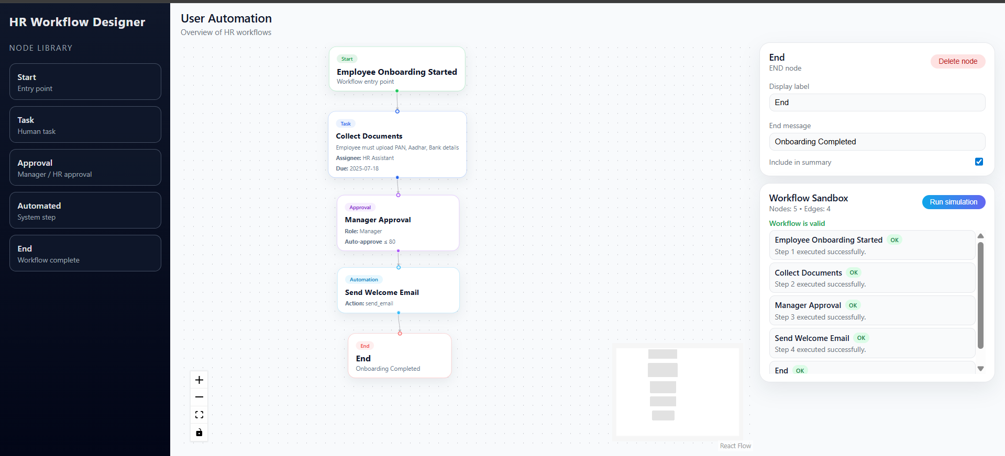

⭐ Possible Improvements
- Undo/Redo
- Import/Export workflow JSON
- Auto-layout using Dagre
- Highlight validation errors on nodes
- Mini-map & zoom controls
- Version history for nodes
- Backend persistence with a real DB

